

DEPARTMENT of NUTRITION





UC DAVIS

NUTRITION

INJURY AND ILLNESS PREVENTION PROGRAM

This Injury and Illness Prevention Program has been prepared by the University of California, Nutrition department in accordance with University Policy (UCD Policy & Procedure Manual Section 290-15: Safety Management Program) and California Code of Regulations Title 8, Section 3203 (8 CCR, Section 3203). The goal of the program is to provide and maintain a safe and healthful work environment for all of our students and employees. Each member within the department is required to follow and adhere to the items set forth in this program.

The purpose of this Injury & Illness Prevention Program is to:
- Establish a management framework for reducing the risks associated with workplace injuries and illnesses,

b) Identify what is required to promote the safety and health,

c) Create an outline of policies and procedures to achieve safety and health goals.

It is understood that the effectiveness and success of the Injury and Illness Prevention Program depends upon the active support and commitment at all levels within the department and its units. All employees and students agree to support and assist in the implementation of the department’s Safety and Health Injury and Illness Prevention Program (IIPP) and thereby agree to:

- Follow Standard Operating Procedures and use maximum care to prevent injuries.
- Use required safety equipment (such as personal protective equipment) provided.
- Report unsafe or hazardous situations, equipment or practices to their supervisor, instructor or safety coordinator immediately. In the event of any work-related accident or injury, all employees and/or students must notify their supervisor immediately.
- Read and understand all training instructions (and not hesitate to ask questions about work safety) and verify documentation of such in training records.

◆ This document is also available online via the Nutrition department website under “Safety Resources” (http://nutrition.ucdavis.edu/about/admin/safety.html) .

UC DAVIS

Nutrition

INJURY AND ILLNESS PREVENTION PROGRAM

TABLE OF CONTENTS

Preface Department Information
- Authorities and Responsible Parties
- System of Communications
- System for Assuring Employee Compliance with Safe Work Practices
- Hazard Identification, Evaluation, and Inspection
- Accident Investigation
- Hazard Correction
- Health and Safety Training
- Recordkeeping and Documentation
- Resources and Appendices

APPENDICES
- Hazard Alert and Hazard Correction Form
- Job Safety Analyses
- Worksite Inspection Forms
- Injury and Illness Investigation Form
- Safety Training Record Forms

Department Information

Department Name: Nutrition

Department Director: Dr. Francene Steinberg (Dept. Chair)

Address: 3135 B Meyer Hall

Telephone Number: (530) 752-0160

Buildings Occupied by Department

- Building: Meyer Hall
Unit(s): Main Department office and individual offices (Meyer Hall - South wing) and
Research Laboratories (Meyer Hall - North wing)
(Rooms: 1339, 1426, 3109, 3111, 3113, 3115, 3135A-E, 3138, 3139, 3143, 3145, 3147, 3148, 3149, 3150A-I, 3202A-C, 3205, 3207, 3209, 3211, 3215, 3217A-C, 3241, 3243, 3245, 3247, 3249, 3251, 3252, 3252A, 3253A-C, 3323, 3325, 3326, 3328, 3329, 3329A, 3401, 3401A, 3403, 3405, 3407, 3407A, 3408, 3412, 3415, 3415A, 3416, 3418, 3420, 3420A, 3422, 3422A, 3423, 3424, 3425, 3425A, 3427, 3428, 3429, 3430, 4303, 4303A, 4305, 4305A, 4306, 4306A, 4307, 4309)
Contact: Dr. Mike Satre, DSC
Phone: (530) 220-6277

- Building: Academic Surge
Unit(s): Ragle Facility (Rooms: 1283 A-1283 S, except 1283 M and 1283 P)
Site Contact: Jody Randolph
Phone: 752-7620
Dept. Contact: Dr. Mike Satre, DSC
Phone: (530) 220-6277

- Building: Willow Cottage (TB33)
Unit(s): Rooms: 001, 002, 003, 101, 104, 106, 107, 109, 110, 111, 112
Contact: Dr. Carolyn Slupsky
Phone: (530) 219-5757
Dept. Contact: Dr. Mike Satre, DSC
Phone: (530) 220-6277

I. Authorities and Responsible Parties

The authority and responsibility for the implementation and maintenance of the Injury and Illness Prevention Program (IIPP) is in accordance with University Policy (UCD Policy & Procedure Manual Section 290-15: Safety Management Program) and California Code of Regulations (8 CCR, Section 3203) and is held by the following individuals:

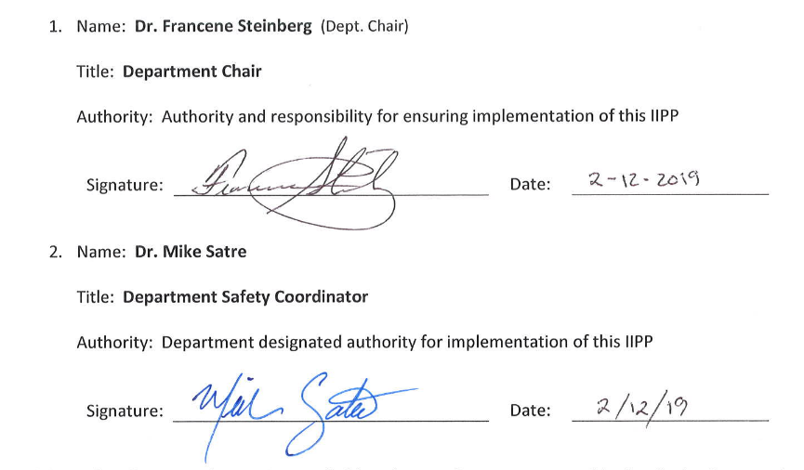

Additionally, all Principal Investigators (PI’s) and supervisors are responsible for the implementation and enforcement of this IIPP in their areas of responsibility in accordance with University Policy
(UCD Policy & Procedure Manual Section 290-15: Safety Management Program - http://manuals.ucdavis.edu/PPM/290/290-15.pdf).

PI’s and supervisors are also responsible for assuring employees and students are properly trained and that such training is documented in training records; that work hazards are evaluated and identified; Standard Operating Procedures are reviewed annually and updated as required.

II. System of Communications

- Effective communications with Nutrition Department employees have been established using the following methods:

- Standard Operating Procedures Manual
- Safety Data Sheets (available on-line at ucsds.com)
- Departmental and Lab-Group meetings
- Internal media (department intranet website – under “Administration”; “Safety Resources”)
- EH&S / UCD Safety Services Safety Nets
- Handouts
- Building Evacuation Plan (Departmental EAP)
- E-mail
- Posters and warning labels
- Job Safety Analysis – Initial Hire
- Job Safety Analysis – Annual Review
- Other - Occasional updates and informational items

- Employees are encouraged to report any potential health and safety hazard that may exist in the workplace. Hazard Alert/Correction Forms (Appendix A) are available to employees for this purpose. Forms are to be placed in the Safety Coordinator’s departmental mail box. Employees have the option to remain anonymous when making a report.

- Employees have been advised of adherence to safe work practices and the proper use of required personal protective equipment. Conformance will be reinforced by discipline for non-compliance in accordance with University policy (UC Davis Personnel Policies for Staff Members- Section 62, Corrective Action).

III. System for Assuring Employee Compliance with Safe Work Practices

Employees have been advised of adherence to safe work practices and the proper use of required personal protective equipment (PPE). Conformance will be reinforced by discipline for non-compliance in accordance with University policy (UC Davis Personnel Policies for Staff Members- Section 62, Corrective Action).

The following methods are used to reinforce conformance with this program:
- Distribution of Policies

- Training Programs

- Safety Performance Evaluations

Performance evaluations at all levels must include an assessment of the individual's commitment to and performance of the accident prevention requirements of his/her position. The following are examples of factors considered when evaluating an employee's safety performance.
- Adherence to defined safety practices.
- Use of provided safety equipment.
- Reporting unsafe acts, conditions, and equipment.
- Offering suggestions for solutions to safety problems.
- Planning work to include checking safety of equipment and procedures before starting.
- Early reporting of illness or injury that may arise as a result of the job.
- Providing support to safety programs.

- Statement of non-compliance will be placed in performance evaluations if employee neglects to follow proper safety procedures, and documented records are on file that clearly indicate training was provided for the specific topic, and that the employee understood the training and potential hazards.

- Corrective action for non-compliance will take place when documentation exists that proper training was provided, the employee understood the training, and the employee knowingly neglected to follow proper safety procedures. Corrective action includes, but is not limited to, the following: Letter of Warning, Suspension, or Dismissal.
IV. Hazard Identification, Evaluation, and Inspection

Job Hazard Analyses and worksite inspections have been established to identify and evaluate occupational safety and health hazards.

- Job Safety Analysis:
Job Safety Analysis (JSA) identifies and evaluates employee work functions, potential health or injury hazards, and specifies appropriate safe practices, personal protective equipment, and tools/equipment. JSA’s can be completed for worksites, an individual employee’s job description, or a class of employees’ job description. JSA’s are located in Appendix B.

The following resources are available for assistance in completing JSA’s:
- Laboratory personnel, (please refer to the Laboratory Hazard Assessment Tool “LHAT”)
- Non-Laboratory personnel, (please refer to the JSA/PPE Certification Forms)

◆ Job Safety Analysis TEMPLATE forms are located in Appendix B.

◆ Consult the EH&S/Safety Services website (http://safetyservices.ucdavis.edu/article/injury-illness-prevention-program-iipp) and sub-links for updates to these forms.

- Worksite Inspections
Worksite inspections are conducted to identify and evaluate potential hazards. Types of worksite inspections include both periodic scheduled worksite inspections as well as those required for accident investigations, injury and illness cases, and unusual occurrences. Inspections are conducted at the following worksites:

  - Location: Meyer Hall (North and South Wings)
Frequency: Annually (or more frequently as required)
Responsible Person: Lab Managers/Supervisors and Dr. Mike Satre (DSC)
Records Location: 3205 Meyer Hall

  - Location: Academic Surge (‘Ragle’ Facility)
Frequency: Annually (or more frequently as required)
Responsible Person: Lab Managers/Supervisors and Dr. Mike Satre (DSC)
Records Location: 3205 Meyer Hall

3) Location: TB 33 (Willow Cottage)
Frequency: Annually (or more frequently as required)
Responsible Person: Lab Managers/Supervisors and Dr. Mike Satre (DSC)
Records Location: 3205 Meyer Hall

◆ Worksite Inspection Forms are located in Appendix C.
◆ Consult the EH&S/Safety Services web site (http://safetyservices.ucdavis.edu/article/injury-illness-prevention-program-iipp) and sub-links within for updates to these forms.
Filled-in example forms are available for guidance in completing your worksite-specific or personnel (job)-specific forms.

V. Accident Investigation

University Policy requires that work-related injuries and illnesses be reported to Workers’ Compensation within 24 hours of occurrence and state regulation requires all accidents be investigated.

Nutrition department personnel will immediately notify their supervisor when occupationally-related injuries and illnesses occur, or when employees first become aware of such problems.

- Supervisors will investigate all accidents, injuries, occupational illnesses, and near-miss incidents to identify the causal factors or attendant hazards. Appropriate repairs or procedural changes will be implemented promptly to mitigate the hazards implicated in these events. Proper injury reporting procedures can be found at http://safetyservices.ucdavis.edu/article/injury-reporting-procedure.

- The Injury and Illness Investigation Form (Appendix D) shall be completed to record pertinent information and a copy retained to serve as documentation. It can be completed by either the supervisor or the Department Safety Coordinator.

3. Note: Serious occupational injuries, illnesses, or exposures must be reported to Cal/OSHA by an EH&S representative within eight hours after they have become known to the supervisor. These include injuries/illnesses/exposures that cause permanent disfigurement or require hospitalization for a period in excess of 24 hours.
◆ Please refer to EH&S SafetyNet #121 for OSHA notification instructions.

VI. Hazard Correction

Hazards discovered either as a result of a scheduled periodic inspection or during normal operations must be corrected by the supervisor in control of the work area, or by cooperation between the department in control of the work area and the supervisor of the employees working in that area. Supervisors of affected employees are expected to correct unsafe conditions as quickly as possible after discovery of a hazard, based on the severity of the hazard.

Specific procedures that can be used to correct hazards include, but are not limited to, the following:

• Tagging unsafe equipment “Do Not Use Until Repaired,” (and/or safely disconnecting unsafe electrical equipment from the power source) and providing a list of alternatives for employees to use until the equipment is repaired.

• Immediately stopping unsafe work practices and providing retraining on proper procedures before work resumes.

• Reinforcing and explaining the need for proper personal protective equipment (PPE) and ensuring its availability.

• Barricading areas that have chemical spills or other hazards and reporting the hazardous conditions to appropriate parties.

Supervisors should use the Hazard Alert/Correction Report (Appendix A) to document corrective actions, including projected and actual completion dates.

◆ If an imminent hazard exists, all work in the area must cease, and the appropriate supervisor must be contacted immediately. If the hazard cannot be immediately corrected without endangering personnel or property, all personnel need to leave the area except those qualified and necessary to correct the condition. These qualified individuals will be equipped with necessary safeguards before addressing the situation.

VII. Health and Safety Training

Health and safety training, covering both general work practices and job-specific hazard training, is the responsibility of the Principal Investigator and immediate Supervisor(s) / Manager(s) as applicable to the following criteria:

- PI’s/Supervisors are provided with training to become familiar with the safety and health hazards to which employees under their immediate direction and control may be exposed.

- All new personnel receive training prior to engaging in responsibilities that pose potential hazard(s).  see Initial Training template in Appendix E

Additional and/or refresher Training is conducted annually (at a minimum) or more frequently when / if:

- Any employee given a new job assignment receives training on the hazards of their new responsibilities prior to actually assuming those responsibilities.

- Training is provided whenever new substances, processes, procedures or equipment (which represent a new hazard) are introduced to the workplace.

- The employer is made aware of a new or previously unrecognized hazard, training is provided.

◆ see Refresher Training template in Appendix E

- Individual employee / personnel training records are located in that individual’s primary work place.

A Safety Training Record forms are located in Appendix E.

◆ PI’s / Supervisors may use these forms ‘as is’ or modify these to create a form, suitable for local conditions.

VIII. Recordkeeping and Documentation

Documents related to the IIPP are maintained in 3205 Meyer Hall.

The following documents will be maintained within the department’s IIPP Binder for at least the length of time indicated below:

- Hazard Alert/Correction Forms (Appendix A).
Retain for three (3) years.

- Employee Job Safety Analysis forms (Appendix B).
Retain for the duration of each individual’s employment.

- Worksite Inspection Forms (Appendix C).
Retain for three (3) years.

- Injury and Illness Investigation Forms (Appendix D).
Retain for three (3) years.

The following documents will be maintained within the employee’s/worker’s primary work location.

- Employee Safety Training Attendance Records (Appendix E).
Retain for length of employment plus three (3) years.

- Resources

- UC Office of the President: Management of Health, Safety and the Environment, 10/28/05
- UC Davis Policy and Procedure Manual, Section 290-15, Safety Management Program
- California Code of Regulations Title 8, Section 3203, (8CCR §3203), Injury & Illness Prevention Prog.
- Personnel Policies for Staff Members, Corrective Action, UC PPSM 62
- UC Davis Environmental Health & Safety / Safety Services
- Safety Services Website
- EH&S SafetyNets
- Safety Data Sheets
- Nutrition departments Safety website under “Safety Resources” http://nutrition.ucdavis.edu/about/admin/safety.html

Appendices

Please DOWNLOAD and fill-in the TEMPLATES provided in this section.

In many cases, PI’s/supervisors may use these as is, or amend them to create a form to suit your site-specific or work-specific environment or local conditions.

◆ Once down-loaded and filled in appropriately, please insert these INTO YOUR LAB HARD-COPY IIPP (and/or other relevant hard-copy file) which is kept for easy access in your lab.

Please consult EH&S/Safety Services (http://safetyservices.ucdavis.edu/article/injury-illness-prevention-program-iipp) for sub-links within as well as updates to these forms.

- Hazard Alert and Correction Forms

While these are available within this IIPP, these can also be accessed here (Appendix A) at the Safety Services IIPP page (above - and sub-links within).

B) Job Safety Analyses (JSA)

Training ‘matrix’ for Lab personnel (UCDavis Training Matrix for Laboratory Personnel)

B-1. example JSA – Office [excel xlsx. doc]

B-2. example JSA 2 – Laboratory [excel xlsx. doc]

JSA/PPE Certification Instructions (for non-laboratory personnel) [ pdf ]

JSA Form (Job Safety Analysis – part I) Template

JSA Example (filled-in example of JSA Form - part I above) [ pdf ]

PPE Hazard Assessment & Certification – part II

PPE Hazard Assessment & Certification – part II (Example)

- (This is a filled-in example of the PPE Cert. form - part II) [ pdf ]

C) Worksite Inspection Forms

C-1. Worksite Inspection Form - Office

C-2. “Self-Inspection checklist” Worksite Inspection Form – Laboratory

Laboratory Safety Review Checklist (http://safetyservices.ucdavis.edu/sites/default/files/documents/LaboratorySafetyReviewChecklist.pdf)

D) Injury and Illness Investigation Form

E) Safety Training Records

Located in this section are guide/example TEMPLATE FORMS which may be used for the indicated topics. PI’s/Supervisors may use these ‘as is’, or amend them to create a form to suit training for a site-specific environment or local conditions.

Initial Individual Site-Specific Lab Safety Training

Initial Individual Office Safety Training

Refresher Training

Appendix A
HAZARD ALERT FORM

Department: Nutrition Alert Identification No. ______________
I. Unsafe Condition or Hazard
Name: (optional) |  |  |  |  |  | Job:
Title: (optional)
Location of Hazard:
Building: |  |  |  | Floor: |  |  |  | Room:
Date and time the condition or hazard was observed: _______________________________________

Description of unsafe condition or hazard:

What changes would you recommend to correct the condition or hazard? ______________________

Employee Signature: (optional) ______________________________ Date: ____________________
II. Management/Safety Committee Investigation
Name of person investigating unsafe condition or hazard: __________________________________
Results of investigation (What was found? Was condition unsafe or a hazard?): (Attach additional sheets if necessary.)
Proposed action to be taken to correct hazard or unsafe condition: (Complete and attach a Hazard Correction Report, IIPP Appendix E)
Signature of Investigating Party: ______________________________________ Date: ____________
IIPP Appendix A | Completed copies of this form should be routed to the appropriate supervisor and Department
January 2016 | Safety Coordinator, and must be maintained in department files for at least three years.

Appendix A
HAZARD CORRECTION REPORT

Alert Identification No. ___________

Department: Nutrition

This form should be used in conjunction with the “Hazard Alert Form” (IIPP Appendix A), as appropriate, to track the correction of identified hazards.

All hazards should be corrected as soon as possible, based on the severity of the hazard. If a serious imminent hazard cannot be immediately corrected, evacuate personnel from the area and restrict access until the hazard can be addressed.

Supervisor/Safety Coordinator Name: |  | Telephone:
Supervisor/Safety Coordinator Signature: |  | Date:

Description and Location of Unsafe Condition | Date Discovered | Required Action and Responsible Party | Completion Date  Projected Actual

IIPP Appendix A | Completed copies of this form should be routed to the department Safety Coordinator and kept in
January 2016 | department files for at least three years.
Appendix B Job Safety Analyses

In addition to the TEMPLATE forms supplied in this section, the following link to EH&S/Safety Services [http://safetyservices.ucdavis.edu/article/injury-illness-prevention-program-iipp] (screen shot below) provides multiple resources and should be consulted for updates and when completing or amending the supplied template forms below.

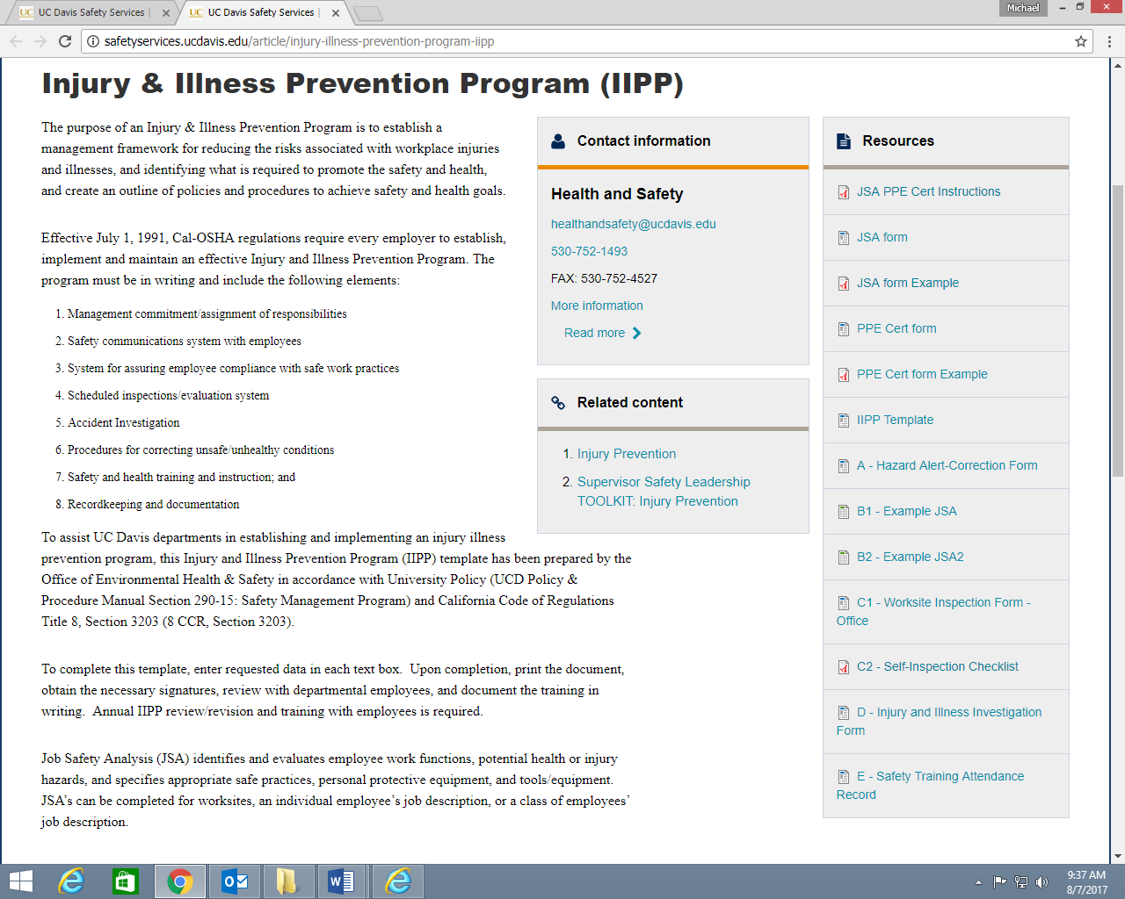
◆ Note the Resources with links for forms

◆ PI’s/Lab Supervisors should also consult the Training Matrix for Lab Personnel (UCDavis Training Matrix for Laboratory Personnel) to aid in determining hazard-specific safety risks and appropriate training.

The Training Matrix for Lab Personnel is also available on the Nutrition department website (“Safety Resources” - http://nutrition.ucdavis.edu/about/admin/safety.html).

Appendix B Job Safety Analyses

For Non-Laboratory (Office) personnel:

JSA/PPE Certification Instructions (for non-laboratory personnel) [ pdf ] - see screen shot below

◆ The complete document is available at: http://safetyservices.ucdavis.edu/sites/default/files/documents/JSA_PPE_Cert_Instructions.pdf
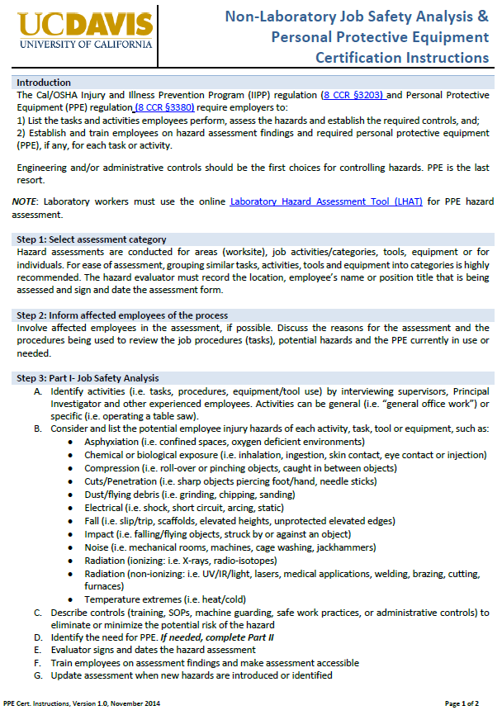

◆ Additional resources:
JSA (part 2) – PPE Hazard Assessment & Certification - Example of filled-in Form [ pdf ] Appendix B2
B2 - Example JSA2 – Business Office Job Safety Analysis [excel xlsx. doc] Appendix B2

Appendix B Job Safety Analyses

In addition to the TEMPLATE forms supplied here, additional resources for assistance in completing JSA’s are available [http://safetyservices.ucdavis.edu/article/injury-illness-prevention-program-iipp - screen shot above] and that shown below:
◆ for Laboratory personnel - Laboratory Hazard Assessment Tool (“LHAT”) screen shot below
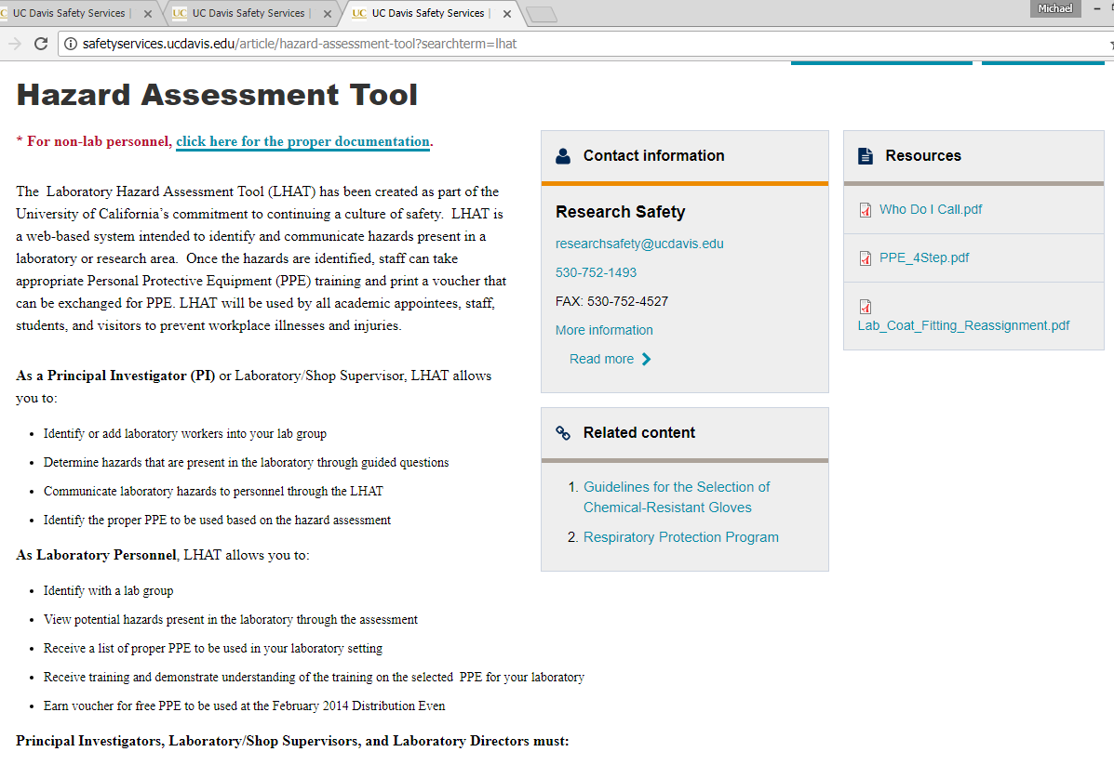
TEMPLATE Forms provided below:
Job Safety Analysis (JSA) - “JSA form - part I” (ver. 2014) [ Appendix B1 ]
PPE Hazard Assessment & Certification form - part II (ver. 2014) [ Appendix B2 ]

◆ These forms should be filled and a copy kept in the Laboratory Safety file.

Additional for Laboratory personnel:
JSA (part 1) - Example of filled-in Form part 1 [ pdf ] - consult the Safety Services website here: Appendix B1
B1 - Example JSA – Lab Safety Analysis [excel xlsx. doc] - consult the Safety Services website: Appendix B1

Additional, amendable TEMPLATE forms are provided on the Nutrition department website (under “Safety Resources” - http://nutrition.ucdavis.edu/about/admin/safety.html).

◆ NOTE: if personnel work with animals (eg. mice, rats, etc.), include these and the associated risks

(eg., allergies, bites) within your JSA (part I) and part II (PPE Hazard Assessment & Certification).

For additional information please go to the Nutrition department website under “Safety Resources”.
Appendix B

 | Job Safety Analysis (Part I)

Instructions: | 1. Select assessment category.  2. List tasks/activities: Develop a list of activities, tasks, equipment/tools (group similar tasks/activities).  3. Identify and list potential hazards: for each task, activity or equipment/tools, list and describe the potential hazards.  4. Identify and list controls: for each task, activity, equipment/tools, document controls (i.e. training, equipment, written procedures,  Personal Protective Equipment (PPE), etc.).  5. If PPE is required, complete Part II- PPE Hazard Assessment and Certification.  6. Train affected employees on the final assessment and document the training.   Repeat assessment when new hazards are identified or introduced into the workplace or at least every three (3) years.   Laboratory workers must use the online Laboratory Hazard Assessment Tool (LHAT) for PPE hazard assessment.
I am reviewing  (check the appropriate box) | ☐ A worksite |  | Specify location:
I am reviewing  (check the appropriate box) | ☐ A single employee’s job description |  | Name of employee:
I am reviewing  (check the appropriate box) |  |  | Position title:
I am reviewing  (check the appropriate box) | ☐ A job description for a class of employees |  | Position titles:
I am reviewing  (check the appropriate box) |  |  | Location:
I am reviewing  (check the appropriate box) | Hazard Evaluator |  | Signature / Date:
TASK/ACTIVITY |  | POTENTIAL HAZARD |  | CONTROL | PPE Required? Y/N

Please consult the “JSA form Example” at http://safetyservices.ucdavis.edu/article/injury-illness-prevention-program-iipp to aid in filling out this form.

Appendix B

Job Safety Analysis (Part I)

Training Record

Designated Trainer: (signature required) __________________________________________________________

I have read and acknowledge the contents, requirements, and responsibilities outlined in this document:

Name | Signature | Date

Appendix B

PPE Hazard Assessment & Certification (Part II)

Instructions: | 1. Select assessment category.  2. List tasks/activities: List tasks identified in Part I (or any other JSA document) that require PPE and list the activity on the form.  3. Identify body parts that may be injured.  4. Identify and list specific required PPE.  5. Provide necessary PPE to employee.  6. Train affected employees on the final assessment, PPE specific training and document the training.   Repeat assessment when new hazards are identified or introduced into the workplace or at least every three (3) years.   Laboratory workers must use the online Laboratory Hazard Assessment Tool (LHAT) for PPE hazard assessment.
I am reviewing  (check the appropriate box) | ☐ A worksite |  |  |  |  | Specify location:
I am reviewing  (check the appropriate box) | ☐ A single employee’s job description |  |  |  |  | Name of employee:
I am reviewing  (check the appropriate box) |  |  |  |  |  | Position title:
I am reviewing  (check the appropriate box) | ☐ A job description for a class of employees |  |  |  |  | Position titles:
I am reviewing  (check the appropriate box) |  |  |  |  |  | Location:
Task/Activity |  |  | Head | Ears* | Eyes |  | Face | Lung* | Trunk |  | Whole Body | Arms | Hands | Knees | Feet | Required PPE
I certify the above hazard assessment was performed to the best of my knowledge and ability, based on the hazards present on this date. Compliance reference-8 CCR §3380.
Evaluator Name: |  |  |  |  |  |  |  |  |  | Department:
Evaluator Signature: |  |  |  |  |  |  |  |  |  | Date:
Please consult the “PPE Cert form Example” at http://safetyservices.ucdavis.edu/article/injury-illness-prevention-program-iipp to aid in filling out this form.

Appendix B

PPE Hazard Assessment & Certification (Part II)

Training Record

Designated Trainer: (signature required) ____________________________________________________________

I have read and acknowledge the contents, requirements, and responsibilities outlined in this document.
I have been provided the necessary PPE and received training on the proper selection, use and maintenance of PPE:

Name | Signature | Date

Appendix C Worksite Inspection Forms

In addition to the TEMPLATE forms supplied here, please consult the Safety Services links (C1 - General Office and Appendix C2 - Laboratory) for updates and when completing or amending the forms below.

TEMPLATE Forms provided below:

C-1 Worksite Inspection form – General Office Environment (TEMPLATE)

C-2 Self-Inspection checklist - Laboratory (TEMPLATE)

◆ Alternate, amendable TEMPLATE forms are provided on the Nutrition department website (“Safety Resources” - http://nutrition.ucdavis.edu/about/admin/safety.html).

Appendix C-1 WORKSITE INSPECTION FORM
General Office Environment

Department: |  | Date:

Inspector: |  | Principal Investigator:

Location Building/Room(s):

 |  | YES | NO | N/A
 | Administration and Training
1 | Are all safety records maintained in a centralized file for easy access? Are they current?
2 | Have all employees attended Injury & Illness Prevention Program (IIPP) training?  If not, what percentage has attended? _______________
3 | Does the department have a completed Emergency Action Plan (EAP)? Are employees being trained on its contents?
4 | Are chemical products used in the office being purchased in small quantities? Are Safety Data Sheets needed or available?
5 | Are the Cal/OSHA information poster, Workers’ Compensation bulletin, annual accident summary posted?
6 | Are annual workplace inspections performed and documented?
 | General Safety
7 | Are exits, fire alarms, pull-boxes clearly marked and unobstructed?
8 | Are aisles and corridors unobstructed to allow unimpeded evacuations?
9 | Is a clearly identified, unobstructed, charged, currently inspected and tagged, wall-mounted fire extinguisher available as required by the Fire Department?
10 | Are ergonomic issues being addressed for employees using computers or at risk of repetitive motion injuries?
11 | Is a fully stocked first-aid kit available? Is the location known to all employees in the area?
12 | Are cabinets, shelves, and furniture over five feet tall secured to prevent toppling during earthquakes?
13 | Are books and heavy items and equipment stored on low shelves and secured to prevent them from falling on people during earthquakes?
14 | Is the office area kept clean of trash and recyclables promptly removed?
 | Electrical Safety
15 | Are plugs, cords, electrical panels, and receptacles in good condition? No exposed conductors or broken insulation?
16 | Are circuit breaker panels accessible and labeled?
17 | Are surge protectors being used? If so, they must be equipped with an automatic circuit breaker, have cords no longer than 15 feet in length, and be plugged directly into a wall outlet.
18 | Is lighting adequate throughout the work environment?
19 | Are extension cords being used correctly? (They must not run through walls, doors, ceiling, or present a trip hazard).
20 | Are portable electric heaters being used? If so, they must be UL listed, plugged directly into a wall outlet, and located away from combustible materials.

IIPP-Appendix C1-Office | Completed copies of this form should be routed to the Department Safety Coordinator
January 2016 | and must be maintained in department files for at least three years.
Appendix C-2 WORKSITE INSPECTION FORM

LABORATORY SELF-INSPECTION CHECKLIST

Principal Investigator / Lab Supervisor:

Location Building/Room(s): |  | Date:

Inspector / Reviewer:

I SAFETY PROGRAM ADMINISTRATION |  | YES | NO | N/A
A. Chemical Hygiene Plan (CHP)
1 | Does the laboratory have access to the campus-wide Chemical Hygiene Plan and all of the required elements?
2 | Are there any operations that require prior approval before beginning (eg. Radiation Safety, Bio-safety committee)?
3 | Is training current with the Chemical Hygiene Plan?
B. Injury and Illness Prevention Plan (IIPP)
1 | Does laboratory have access to Department IIPP (on-line and/or hard copy) and has it been reviewed in past year?
2 | Is there documentation that all laboratory personnel have trained on the IIPP?
C. Standard Operating Procedures (SOP’s)
1 | Are there written SOP’s covering the laboratory processes and hazardous chemicals referenced in Title 8 (i.e., acutely toxic substances, reproductive toxins, and regulated carcinogens)?
2 | Are there exemptions to the written SOPs and are these documented?
3 | Is there documented training of lab personnel on specific SOP’s?
4 | Is any required specialized training complete and documented?
5 | Is training is complete on Hazardous waste management?
6 | Is training complete on Blood-borne Pathogen requirements?
NOTES:
Continued on next page
II HAZARDOUS MATERIALS |  | YES | NO | N/A
1 | Laboratory doors are labeled with emergency contact notification names & numbers, hazards present & necessary precautions.
2 | Labels are clean and intact on all chemical containers.
3 | Chemical containers are clearly identified with contents and hazards.
4 | Containers with non-hazardous substances (i.e., water) clearly labeled to avoid confusion.
A. Chemical Controls
1 | Chemicals are not stored on laboratory benches in excessive quantities.
2 | Expired or chemicals not used (> one year) are disposed of as hazardous waste.
3 | Secondary containment is provided for strong acids and strong bases.
4 | Incompatible chemicals are segregated and stored with compatible hazard classes.
5 | All chemical containers are closed, except when actively adding or removing materials from them (i.e, no open funnels left in container).
6 | Containers of peroxide-forming chemicals are dated upon receipt and disposed of as hazardous waste within one year of receipt.
7 | Safety Data Sheets (SDS) and laboratory chemical inventory are up-to-date and readily available.
8 | Chemicals (liquids) are stored below eye level and not directly on the floor, unless in secondary containment.
9 | Dedicated chemical storage (cabinets, refrigerators, freezers) clearly labeled with contents and hazard warnings.
B. Flammable and Combustible Liquids
1 | Flammable liquids stored in 1-gallon (or smaller containers) or kept in 2-gallon (or smaller) safety cans.
2 | Flammable liquids (including flammable liquid waste) stored outside of a storage cabinet does not exceed 10 gallons.
3 | If more than 10 gallons of flammable liquids are present, does the laboratory have an approved flammable storage cabinet?
4 | Flammable liquids, stored in flammable storage cabinets limited to 60 gallons per fire rated area.
5 | Flammable liquids requiring reduced temperature stored in flammable-rated refrigerator/freezer.
C. Particularly Hazardous Substances
1 | Have all particularly hazardous substances been identified?
2 | Designated area(s) for acutely toxic materials, reproductive toxins and/or carcinogens clearly marked.
3 | Are all users adequately trained? Specific training documentation available?
4 | All necessary PPE (personal protective equipment) available and used as needed.
D. Radioactive Materials
1 | Stock materials of radioactive materials are secured against unauthorized removal?
2 | Do personnel wear lab coats and gloves when handling radioactive materials? If assigned dosimeters, are they wearing them?
3 | Are all radioactive materials registered with the EH&S Health Physics Program?
4 | Radioactive Waste – Properly labeled, segregated, and shielded?
Continued on next page
III CHEMICAL WASTE |  | YES | NO | N/A
A. Storage
1 | Are chemical waste containers properly segregated, sealed with tight-fitting caps and stored with EH&S Hazardous Waste Labels attached?
2 | All hazardous chemical waste is arranged to be picked up by EH&S — not drain disposed or evaporated.
3 | Hazardous chemical waste has been accumulating for less than 270 days. Extremely hazardous waste has been accumulating less than 90 days.
4 | All hazardous chemical waste is secondary contained.
5 | Training for personnel handling hazardous waste is documented?
6 | EH&S is called for waste pick up when containers are full (90% capacity or full line) or have reached their accumulation date threshold.
7 | Is the WASTe system being used?
8 | Waste containers sturdy, compatible with the waste, routinely checked for leaks and kept closed when not actively being filled.
B. Labeling
1 | All hazardous waste containers have proper labels with contents and accumulation start date.
2 | The hazardous waste accumulation area is clean with waste containers clearly marked.
IV BIOHAZARDOUS WASTE |  | YES | NO | N/A
A. Storage
1 | Solid bio hazardous waste is bagged in red polyethylene bags as per the Medical Waste Management Plan.
2 | Biohazardous liquid waste is managed per the Medical Waste Management Plan.
3 | Sharps stored in puncture-proof containers; labeled appropriately, and not past fill line.
B. Labeling
1 | Secondary containers for laboratory medical waste storage or transport labeled with the international biohazard symbol and the word “Biohazard.”
V PERSONAL HEALTH and SAFETY
A. Food and Drink
1 | Sinks labeled “Industrial Water – Do Not Drink”.
2 | Food and drink is not permitted in laboratories.
3 | Food and drink is stored only in refrigerators/freezers dedicated and labeled “for food only”.
B. Standard Practices
1 | Employees wash areas of exposed skin prior to leaving the laboratory.
2 | Sink is available and hands washed after removing gloves and before leaving lab.
3 | Cosmetic applications, taking medication, touching eyes, nose or mouth is avoided when in the laboratory.
NOTES:
VI HEALTH and SAFETY EQUIPMENT |  | YES | NO | N/A
A. Safety Showers and Eye Washes
1 | Approved safety showers and eye washes provided within 10 seconds travel time from the work area for immediate use, with no barriers (ie. doors).
2 | All eyewashes and showers have unobstructed access.
3 | Sign indicating location of safety shower and eye wash unobstructed.
4 | Units inspected and activated monthly. Annually certification by Facilities Management for proper functioning.
B. Personal Protective Equipment (PPE)
1 | Has the correct PPE been selected based on a hazard assessment (LHAT) and/or SDS recommendation?
2 | PPE required for laboratory work present: [ ] Lab Coats, [ ] Gloves  [ ] Safety glasses with side shields/goggles [ ] Face Shield  [ ] Hearing protection [ ] Proper foot-wear [ ] Aprons
3 | All necessary equipment is available, in good condition, and properly used.
C. Biological Safety Cabinets
1 | Certified within the last year (TSS Certificate)
2 | Hood type is proper for work being conducted?
3 | Equipment is properly labeled for the hazard present (radiation, UV,), Manufacturer approved for all indicated hazards.
4 | Hood ducted per manufacturer and ASHRAE requirements and meets the biosafety specifications.
D. Laboratory Fume Hoods
1 | Storage inside of hood is kept to a minimum.
2 | Equipment in use does not interfere with proper functioning of the hood.
3 | All work is done at least 6 inches inside hood.
4 | Front sash is lowered when hood is not in use.
5 | Certified annually by Facilities Management, semi-annually for Title 8 §5209 “listed” Carcinogens.
6 | Hood has continuous flow monitor.
7 | The back ventilation slot is not obstructed.
8 | Drains are protected from hazardous materials entering.
E. Compressed Gas Cylinders
1 | Cylinders stored in well protected, well vented and dry locations away from combustible materials.
2 | Flammable gases stored away from oxidizers.
3 | Cylinders are secured to a rigid structural component of the building with non-flammable restraints located 1/3 and 2/3 (preferred) or ½ the height of the cylinder.
4 | Protective caps in place while cylinders are in storage and full/empty tags attached.
5 | Proper regulators are being used and closed when cylinders are not in use.
NOTES:
F. Housekeeping & Miscellaneous Laboratory Safety |  | YES | NO | N/A
1 | Bench tops clean, organized and environs maintained to eliminate harmful exposures or unsafe conditions.
2 | Supplies stored at minimum of 24 inches from ceiling and off the floor.
3 | Vacuum lines equipped with traps designed specifically to accumulate/filter the hazardous materials being evacuated.
4 | All moving machinery (i.e, vacuum pumps) belts adequately protected by a rigid belt guard or housing.
5 | All sharps disposed properly.
6 | The condition of the broken glass box is adequate and placed out of the way.
7 | Ceiling tiles present and in good condition.
8 | Refrigerators/freezers labeled according to use.
G. Electrical Safety
1 | High voltage equipment (>600V) labeled, grounded and insulated.
2 | No electrical equipment has damaged or frayed cords.
3 | Extension cords are not connected together (no “daisy chains”).
4 | Power strips used only if they are equipped with circuit breakers.
5 | All equipment is grounded via 3-prong plugs.
6 | Damaged equipment tagged out (and unplugged) to prevent use.
H. General Safety
1 | Cabinets and bookshelves are secured.
2 | Overhead storage is minimized and restrained from falling (i.e, shelf lips, rails).
3 | Heavy equipment is secured or braced from falling.
I. Respiratory Protection
1 | Use of respiratory protection conforms to UC Davis Policy.
2 | Respirators are inspected monthly and before use.
3 | The user has been fit tested by the Occupational Health Services.
4 | Cartridges are changed on designated schedule and are the appropriate cartridge for the hazard.
J. Laser Safety
1 | Does the laboratory use any Class 3b or 4 lasers?
2 | Are the lasers registered with EH&S Health Physics Program?
3 | Are the Standard Precautions for lasers prominently posted for each laser?
4 | Are appropriate warning signs and labels posted?
5 | Does the laboratory entrance have a warning light or lighted sign showing when the laser is in use?
6 | Have all workers attended the EH&S Laser Safety course?
7 | Does the laboratory have appropriate laser eyewear?
NOTES:
K. Non-Ionizing Radiation (NIR) Source |  | YES | NO | N/A
1 | Have proper warning signs been posted?
L. Emergency Planning & Procedures
1 | Emergency Response Guide and evacuation map visibly posted and current.
2 | Chemical spill kit/cleanup materials available.
3 | Training in spill clean-up procedures provided and documented.
4 | First aid materials kept in adequate supply (in a sanitary and usable condition); contains no expired materials, and is made readily available.
M. Fire Prevention
1 | Appropriate fire extinguisher mounted, unobstructed, available within 75 feet, is in working order and inspected within the last year.
2 | A fire extinguisher should be available in a room containing flammable and/or combustible liquids.
3 | Fire extinguisher sign is clearly visible.
4 | 18-inch vertical clearance maintained from sprinkler head (i.e, over shelving and wall/floor cabinets).
5 | Are all laboratory doors kept closed? Closure devices in place?
6 | Storage of combustible material is minimized.
N. Exits
1 | Exits and aisles are clear and free of obstructions in case of emergency.
2 | Exit signs clearly visible.
NOTES:

IIPP-Appendix C2-Laboratory  January 2016 | Keep a copy of this completed form in the Laboratory Safety binder.
IIPP-Appendix C2-Laboratory  January 2016 | A completed copy of this form should be routed to the Department Safety Coordinator
IIPP-Appendix C2-Laboratory  January 2016 | and must be maintained in department files for at least three years.

Appendix D Injury Reporting

◆ Be sure to consult and be prepared to do the following in the event of an injury:
1) Access the Injury Reporting Procedure page on the Safety Services website
http://safetyservices.ucdavis.edu/article/injury-reporting-procedure
2) Complete the electronic Employer's First Report (screen shot below – NOT the actual form for use)
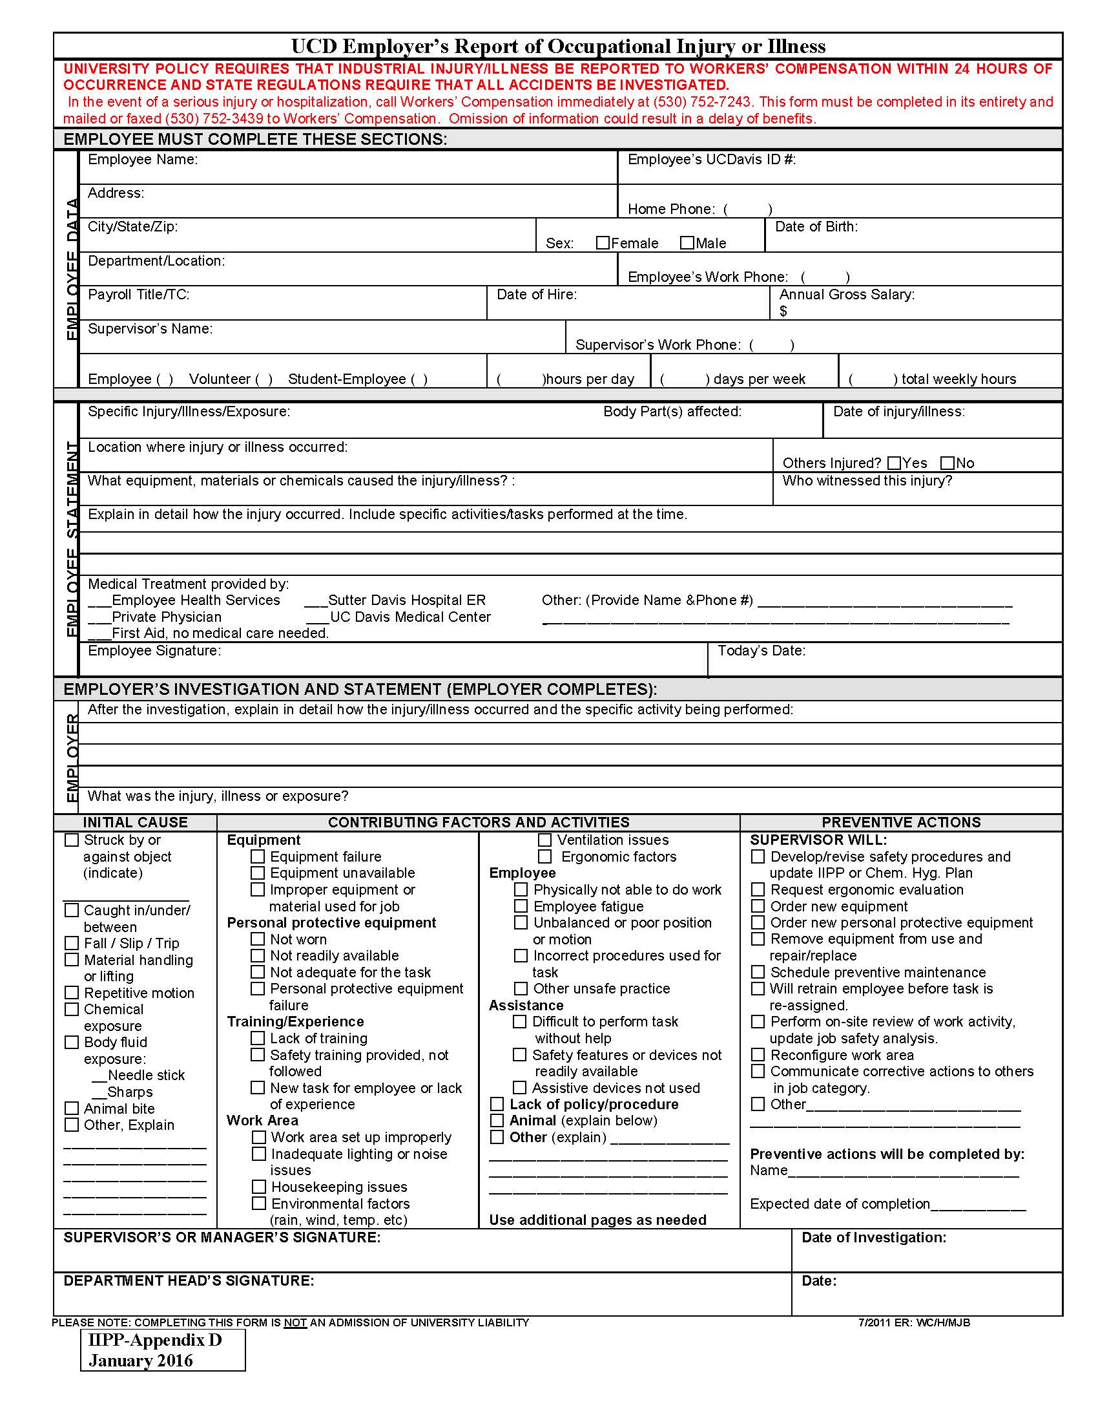
as soon as practical.

Appendix E Safety Training Records

1) INITIAL Training form [Template] for personnel new to Lab or work area.

2) REFRESHER Training form [Template] for personnel having had Initial Training no more than
1 year prior.

Please DOWNLOAD and FILL-IN the TEMPLATE FORMS provided in this section.

In many cases, PI’s/supervisors may use these as is, or amend them to create a form to suit your site-specific or work-specific environment or local conditions.

◆ Once down-loaded and filled in appropriately, please insert these INTO YOUR LAB HARD-COPY RECORDS file for easy access in your lab.

Consult EH&S/Safety Services (http://safetyservices.ucdavis.edu/article/injury-illness-prevention-program-iipp) for further information.

Appendix E
Initial Site-Specific Orientation and Laboratory Safety Training
for new lab personnel

Trainee Name (print): ______________________________ Date: ____________________

Faculty / PI: ______________________________________ Room #’s: __________________________

Prior to completing this site safety orientation and training, all laboratory personnel must have successfully completed the UC Laboratory Safety Fundamentals course. Completion of this training course is required prior to personnel being granted unescorted access to the laboratory. This serves to satisfy components of the University of California Policy - Laboratory Safety Training and UC Davis policy PPM290-56.
□ Has successfully completed the UC Laboratory Safety Fundamentals course. Date: __________________
                        □ Certificate in file

◆ Please initial only topics covered. For others not covered/not applicable, mark with an “X”.
Emergency Procedures
Initials | Topic | Action
 | Fire Alarm Pull Station | Show location(s) and proper activation.
 | Eye Wash / Safety Showers | Show location(s) and proper operation.
 | Spill Procedures | Show location of spill kit(s), has read SafetyNets #13 and #127 (if applicable), and describe procedures.
 | First Aid Kits | Location(s) and description of contents.
 | Phone | Location(s), detail dialing instructions, ‘911’ dialing instructions, bomb threat card.
 | Emergency Response Guide | Show location(s) of flipchart guide, discuss various scenario actions
 | Emergency Action Plan (EAP) | Review Emergency Action Plan. Demonstrate both paths to Emergency Assembly Area.  [If applicable - Review evacuation procedures for disabled personnel].
 | Warn Me | Enroll in UCDavis Warn Me emergency alert system, recommend registering cellular phone number.

Engineering Controls
Initials | Topic | Action
 | Chemical Fume Hood(s) | Demonstration of proper use, instruction on adjustable controls, air-flow sensor function, applicable training requirements
 | Biological Safety Cabinet(s) | Demonstration of proper use, instruction on adjustable controls, appropriate training applicable requirements
 | Chemical Storage Location(s) | Location(s) and incompatible chemical segregation rules, volume limits (>10 gallons requires storage in flammable storage cabinet).
 | Other Controls (e.g. Laminar Flow Benches) | Demonstration of proper use, instruction on adjustable controls
Describe Details:
Administrative Controls
Initials | Topic |  | Action
 | Laboratory Safety Manual  [ includes Chemical Hygiene Plan ] |  | Location (web-Link) and content description. Laboratory Safety Plan(s) – if applicable.
 | Department IIPP  [ Injury and Illness Prevention Plan ] |  | Location (web-Link), content description and review.
 | Safety Data Sheets (SDSs) |  | Demonstration of electronic/computer access; describe laboratory repository of hard-copy SDSs (if applicable).
 | Standard Operating Procedures |  | Location(s) of lab’s SOPs; describe required approvals. Identification of chemical processes / areas requiring specific SOP use, and related laboratory safety rules.
Describe Details:

Personal Protective Equipment [ PPE ]
Initials | Topic | Action
 | Determine Hazard-specific Safety Risks and Training | Consult UCDavis Training Matrix for Laboratory Personnel; enroll in appropriate courses.
 | Lab Coat | Provide at no cost fitted laboratory coats. Some labs/hazards require flame resistant coats – determine type(s) needed.
 | Eye Protection | Provide at no cost pair(s) of safety eyewear. Glasses must fit appropriately, be comfortable to wear, and stay securely in place. For labs where goggles must be worn, provide pair(s) of fitted chemical splash goggles. When a face shield is required, demonstrate proper use, care and storage.
 | Gloves | Location(s) and description. Provide knowledge and resources to select correct type as related to use. Instruct proper procedures for putting on / taking off.

Other
Initials | Topic | Action
 | Hazardous Waste | Overview of laboratory hazardous waste procedures. Location(s) of accumulation area(s); demonstrate proper labeling; describe proper storage requirements and detail pickup/removal procedures.
 | Specialized Equipment | Review of safety procedures for proper operation. (eg. UV light, high voltage equipment, cryogen handling, high/low vacuum, etc…
Describe Details:

I understand this training and agree to comply with the Safe Work Practices for my work and work area.
Trainee Signature _____________________________________________
Directions: Retain a copy in your Lab safety file along with any certificates for completion of Safety Training courses
Appendix E
Refresher Laboratory Safety Training

PI / Faculty in-charge: ______________________________________ Date: ____________________

Trainer name (print): ______________________________________

Check BOX of Topics / Subjects covered
Required Topics
Injury and Illness Prevention Plan (IIPP)
Emergency Action Plan (EAP)
Chemical Hygiene Plan (CHP – as part of Laboratory Safety Manual)
Chemical Spill Control – SafetyNet 13
Standard Operating Procedures (SOPs)
Other Topics
Fill-in with the individual specific topics relevant to your lab/group.
If multiple topics are listed, be sure to check the box(es) of only those that are
covered in that particular Refresher training session
NOTE – for your Lab- / site-specific SOPs, these may be in addition to any new or
revised SOPs (new versions) which would have triggered earlier, documented
personnel training.

In signing below, I certify that I have received training as described above
 | Name (print) | Signature | Employee or student ID # / Title
1.
2.
3.
4.
5.
6.
7.
8.
9.
10.

Directions: Retain a copy in your Lab safety file along with any certificates for completion of Safety Training courses

